Inhalt
General 2
Step 1 – Create a Microsoft Graph Client ID 2
Step 2 – Configure XML template 6
Step 3 – Upload the Microsoft Teams template into the phone 7

General
Requirements:
- Update COMfortel D series to version 1.8 or higher
- Import of the Microsoft Teams template file teams_refresh.xml
- Supported terminals: COMfortel D series
Important note: The Microsoft Teams API is used for the Microsoft Teams integration. The API is in a beta stage and currently only allows querying the presence state. It’s not possible to change the Teams state via this API.

Step 1 – Create a Microsoft Graph Client ID
To get access to the presence information of Microsoft Teams, you have to register an application with Microsoft. This is the only way to gain access to the required API.
Important: The client ID is the ID of the registered application. This only needs to be created once for the entire company. It is then used for all COMfortel D series devices. This means steps 1 and 2 only have to be carried out once.
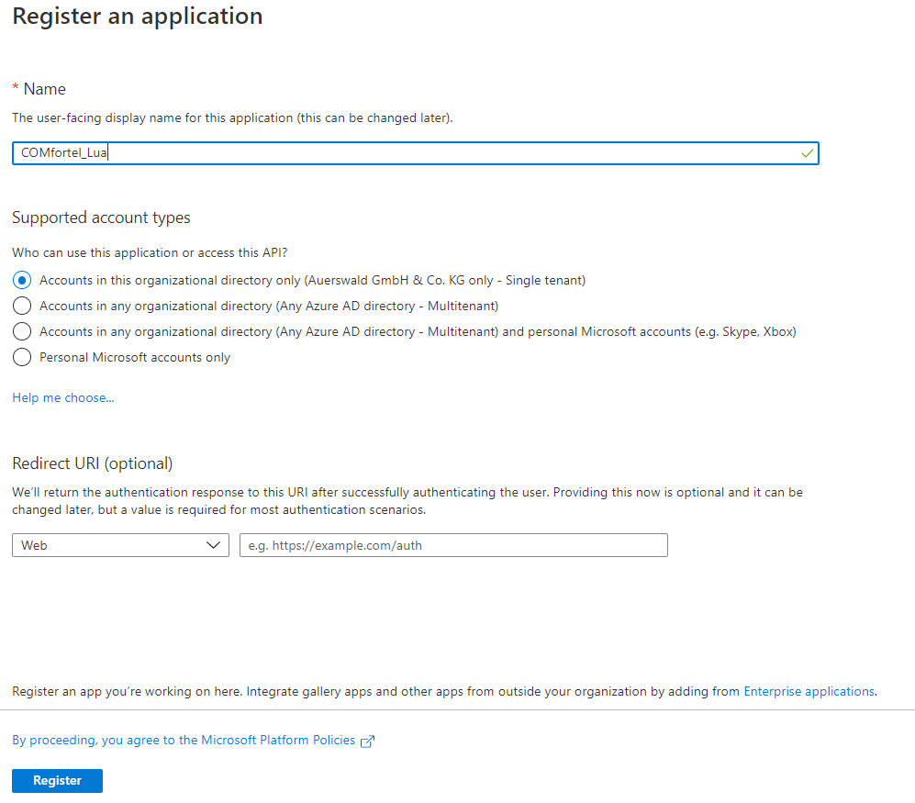
The website https://docs.microsoft.com/de-de/graph/toolkit/get-started/add-aad-app-registration explains how to perform an application registration in the Azure Active Directory and thus create a client ID. The client ID is needed in step 4 to perform the initial authentication.
The default settings can be adopted during the initial setup.
By pressing the Register button, the application is registered and the client ID is already created.

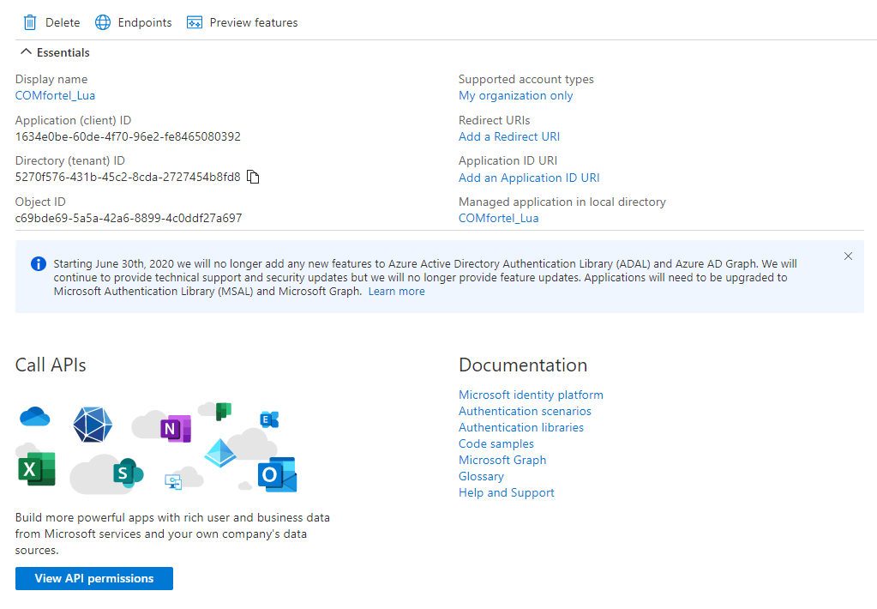
After an application registration has been created, it must still be configured. If you are not automatically forwarded to the configuration page, you must select the application you have just created (e.g. COMfortel_Lua) from the list of registrations.
Then the client ID (application ID) can be seen and further settings can be made:

The next step is to add a Redirection URI.

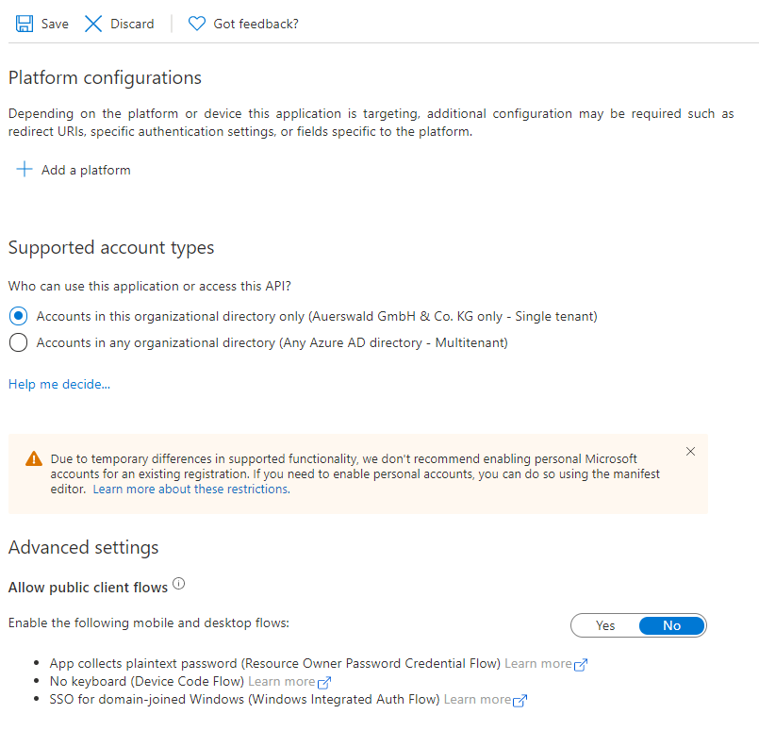
Via Add a platform, Mobile and desktop applications must now be selected as the platform.

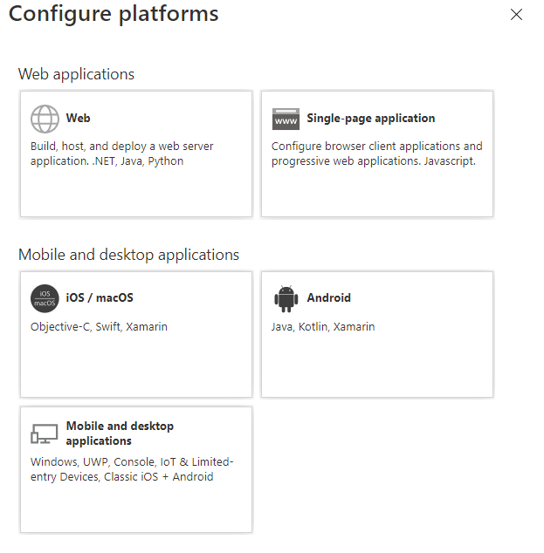

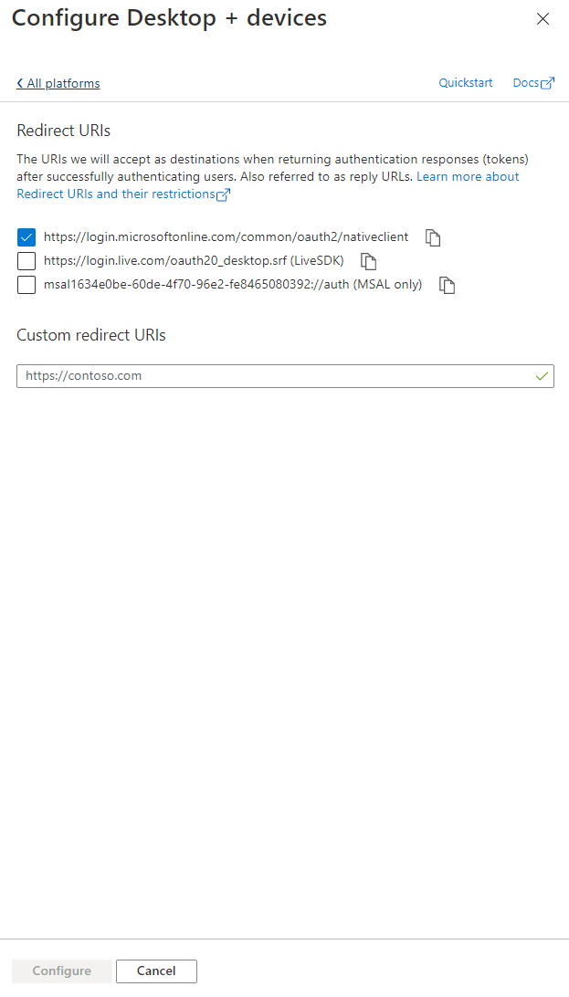
Then the first option aka
https://login.microsoftonline.com/ common/oauth2/nativeclient must be selected.
Pressing the Configure button accepts the selection.

Now the API permissions Presence.Read.All and User.ReadBasic.All must be added.
To do this, select View API permissions.

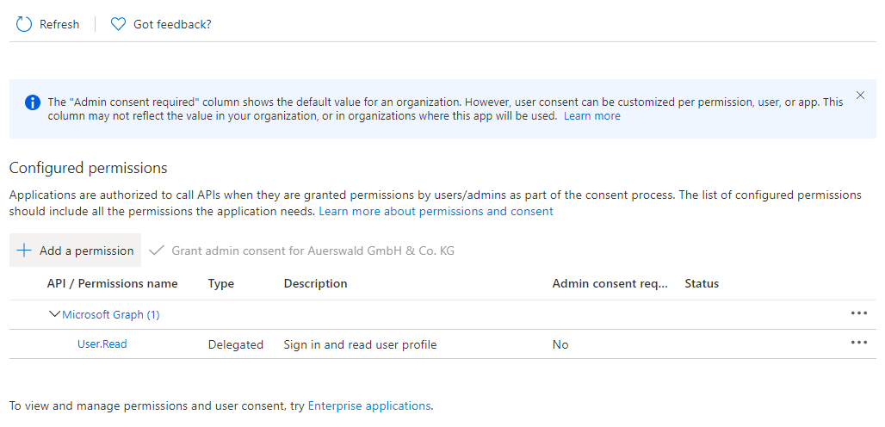
Further permissions can then be found via Add a permission.

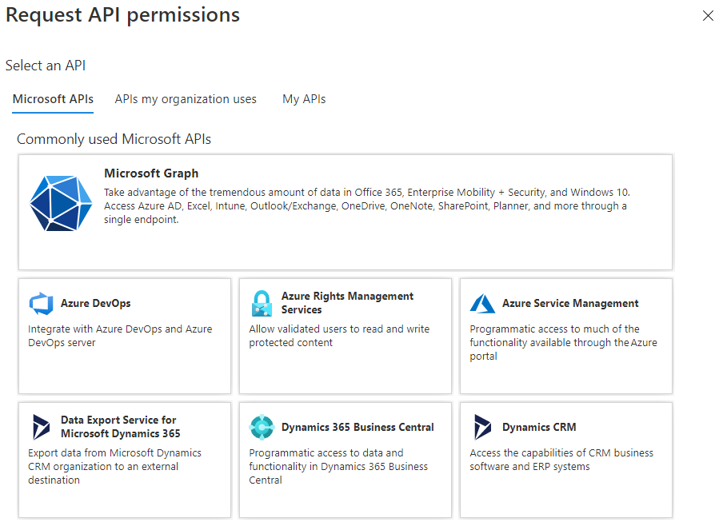
Next, select Microsoft APIs and then Microsoft Graph.

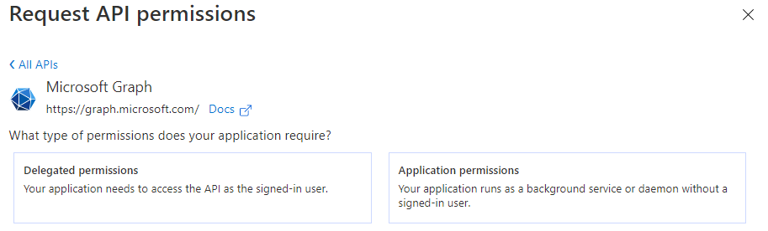

Then select Delegate permissions.

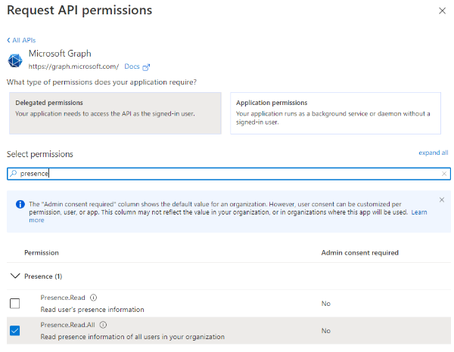
Use the search field to find and select the two API permissions Presence.Read.All and User.ReadBasic.All.

These two API permissions must still be set to "granted" for your organisation. Administrator rights are necessary for this!

The status can be checked via the View API permissions button.

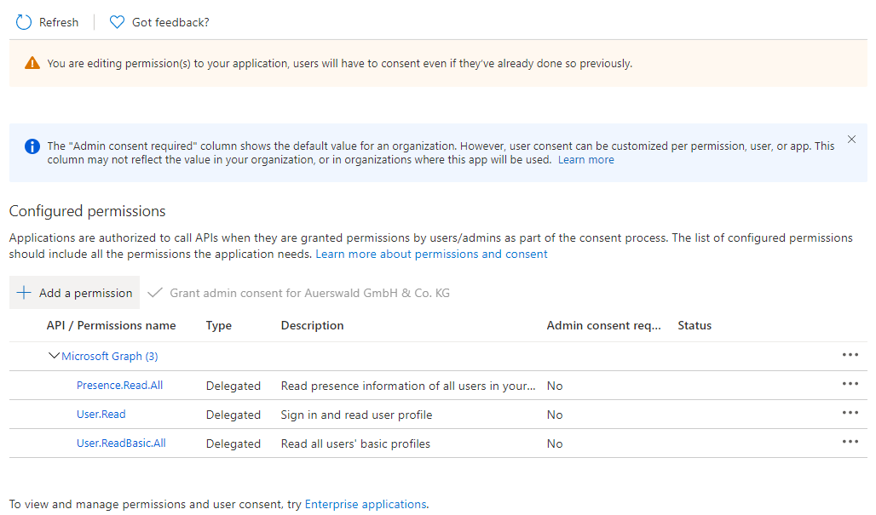
Then select Grant admin consent for "...".

Step 2 – Configure XML template
Open the XML template teams_refresh.xml with a suitable editor.
Now find and edit the lines 7 and 55.
7 | local content = "client_id=[Client-ID]&scope=presence.read&redirect_uri=...
…
55 | local tokenRequestContent = "client_id=[Client-ID]&scope=presence.read...
The client ID (application ID) from step 1 must be inserted between client_id= and &scope.
Examples:
local content = "client_id=5f3ca41b-5f46-476f-972f-ffbffc4ce69b&scope=presence.read
local tokenRequestContent = "client_id=5f3ca41b-5f46-476f-972f-ffbffc4ce69b&scope=presence.read
Then save the XML template.

Step 3 – Upload the Microsoft Teams template into the phone
The Steps 3 to 11 must be repeated per phone.
Log in to the web interface of the target phone (e.g. COMfortel D-600 IP address 192.168.0.201).
Upload the XML template teams_refresh.xml modified in step 2 into the phone.
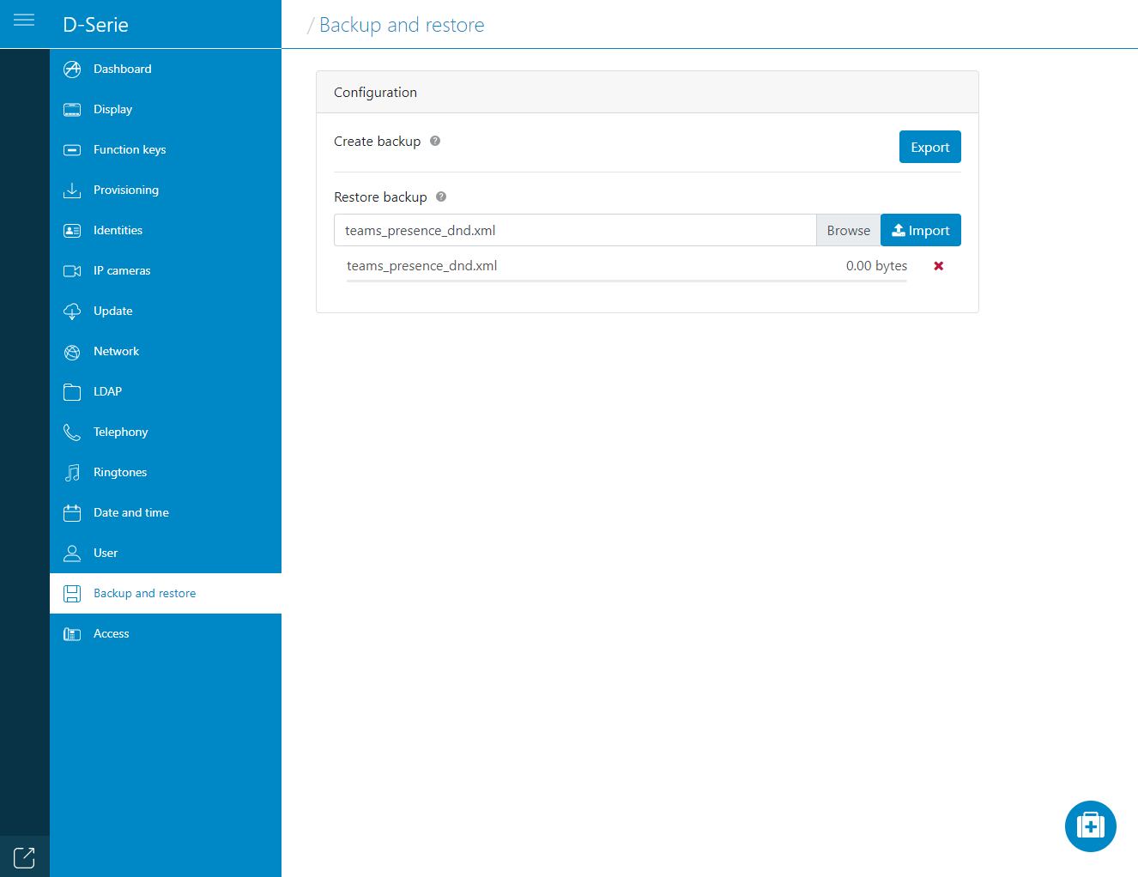
- Select Backup and restore in the navigation on the left-hand side.
- Select the button Browse under Restore backup and select the file teams_refresh.xml.
- Transfer the template to the phone with the Import button.

